**Book of Insights (Lesson)**

Page 1:

* Welcome to the Book of Insights.
* Here, you can learn all about natural disasters to help overcome obstacles in the interactive story. Let’s get started!

(**Tornado**)

Page 2:

* The tornado is the first natural disaster we’re going to explore. A violent rotating column of air, a tornado is deadly to anything that gets in the way. The column extends from the base of a thunderstorm down to the ground. Oftentimes, tornadoes are just a result of the four Anemoi having a fight amongst themselves. They have a pretty bad temper!
* The best way to survive a tornado is to hide and stay in a sturdy building. Stay away from windows and doors, and get to the lowest floor (such as a basement). Always avoid being inside a vulnerable shelter, like a car or tent. In addition, get under something heavy within your shelter for extra protection.

(**Volcano**)

Page 3:

* A volcano is an opening in the Earth’s crust through which an avalanche of lava, volcanic ash, and gases escape. One of the deadliest disasters, volcanoes are catastrophic during both the actual eruption phase, and the aftermath. Volcanic ash can cause damage thousands of kilometers away, including destroying crops, contaminating water supplies, while also causing respiratory problems for anyone with the misfortune of being caught in the ash.
* If you are caught in the initial wave of pyroclastic flow, there is little you could do. However, you should always be aware of the residing ash in the air, which can be lethal to humans when inhaled. It’s advised to wear a mask or to cover your mouth during and after a volcanic eruption. Also, geothermal lands are especially prone to collapsing during a volcanic eruption, so avoid those at all costs!

(**Earthquake**)

Page 4:

* When the Earth rumbles and shakes, you know something is about to happen. Earthquakes are classified as days when the tectonic plates below us get into a fight. But one lingering question you might have is, who sent it? Was it Poseidon, the earthshaker - or was it Hades, the god of the underworld? It’s difficult to tell, so all you can do is flip a coin and hope you prayed to the right god!
* Earthquakes are destructive natural disasters that are deadliest in a dense and civilized area. Buildings topple, cracks form - and you are left to wonder what you have done. Get somewhere as low as possible, like a basement, and hide under something heavy so falling debris is unlikely to hit you.

(**Tsunami**)

Page 5:

* The tsunami is a natural disaster that occurs when tectonic plates under water get into an argument. I know, these tectonic plates are so troublesome and naughty!
* Tsunamis are a wall of water rushing towards the shore. So what do you do? Get as far away from the water as possible, even if you can’t outrun it. Getting to as high of an elevation as possible might also be helpful. If you are dragged into the current, your best chance at survival is to find something floating and cling onto it. Your fate’s been sealed if Poseidon is having a bad hair day!

(**Hurricane**)

Page 6:

* It’s not a good idea to make both Zeus and Poseidon mad! Forming over tropical waters, hurricanes (tropical cyclones) are a mixture of water and wind. They strengthen when it feeds on unstable air, such as turbulence and rising motion.
* The safest place during a hurricane is the eye of the storm. It’s the calmest part during the storm, with light winds and fair weather. Stay away from any objects that can be lifted off the ground, and make sure to avoid drowning in water. That would be unfortunate.

Page 7:

* Congratulations! You made it through the Book of Insights.
* The gods were betting you wouldn’t be able to. By the way, Athena always had faith you would. She’s the goddess of wisdom for a reason.

**Animations/gif Links:**

[Volcano](https://gfycat.com/stickers/search/volcano+eruption)

[Tornado](https://gfycat.com/stickers/search/tornado+spiral)

[Tsunami?](https://www.pinterest.ca/pin/151996556153187230/)

[Tsunami 2?](https://tofupixel.tumblr.com/post/623704441406865408/the-great-wave-remade-in-pixels-for-ta1keys)

[Hurricane?](http://img0.joyreactor.com/pics/post/pixel-art-storm-gif-1737560.gif)

[Huricane…. ;-;](https://tenor.com/view/hurricane-doppler-radar-sticker-spinning-gif-15144732)

[Hurricane](https://gfycat.com/stickers/search/hurricanes)

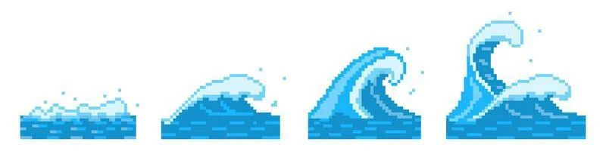

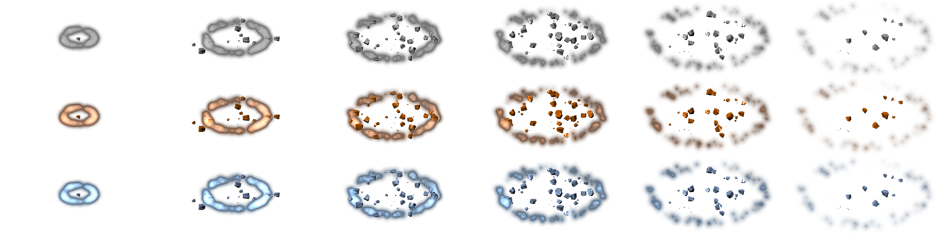

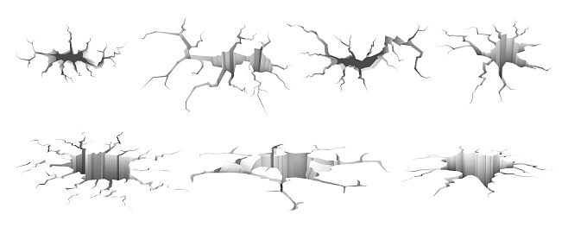

Images:

